1.As observed from the top of a 75 m high lighthouse from the sea-level, the angles of depression of two ships are 30° and 45°. If one ship is exactly behind the other on the same side of the lighthouse, find the distance between the two ships.
Options:
A. 75 (√3-1) units
B. 8 units
C. 12 units
D. Data inadequate
Answer: A. 75 (√3-1) units

Solution:
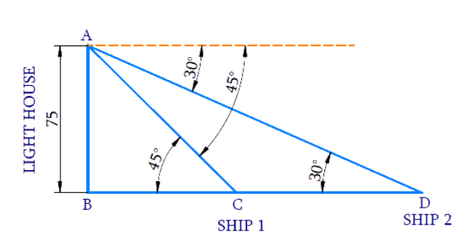
Let the height of the lighthouse from the sea level be AB and the ships are C and D.
The angles of depression of the ships C and D from the top A of the lighthouse are 30° and 45° respectively.
Distance between the ships = CD = BD − BC
In ΔABC,
tan 45° = AB/BC
1 = 75/BC
BC = 75
In ΔABD,
tan 30° = AB/BD
1/√3 = 75/BD
BD = 75√3
Distance between two ships CD = BD - BC
CD = 75√3 - 75
= 75 (√3 - 1)
Distance between two ships CD is 75 (√3 - 1) m.
2. A ladder leans against a wall making an angle of measure 60° with the ground. If the foot of the ladder is 3 metres away from the wall, then the length of the ladder is ..... metre.
Options:
A. 3√2
B. 3√3
C. 6
D. 3√3/2
Answer: C. 6
Solution:
Given:
Angle between ladder and ground = 60°
Distance from wall to foot of ladder = 3 meters
Let the length of the ladder be l meters.
Using trigonometry:
In the right triangle formed by the ladder, wall, and ground:
Adjacent side (base) = 3 meters
Hypotenuse (ladder) = l meters
Angle = 60°
cos θ = Adjacent/Hypotenuse
cos 60° = 3/l
We know that cos 60° = 1/2
Therefore: 1/2 = 3/l
l = 3 × 2
l = 6 meters
Alternative approach using sec:
cos 60° = 3/l
l = 3/cos 60°
l = 3 × sec 60°
Since sec 60° = 1/cos 60° = 1/(1/2) = 2
l = 3 × 2 = 6 meters
Therefore, the length of the ladder is 6 meters.
3. The angle of elevation of the sun, when the length of the shadow of a tree is √3 times the height of the tree, is:

Options:
A. 30°
B. 45°
C. 60°
D. 90°
Answer: A. 30°
Solution:
Let:
AB = height of the tree
AC = length of the shadow
θ = angle of elevation of the sun (angle ∠ACB)
Given: AC = √3 × AB
Using trigonometry:
In the right triangle formed by the tree, shadow, and sun's rays:
tan θ = Opposite/Adjacent = AB/AC
Since AC = √3 × AB:
tan θ = AB/(√3 × AB) = 1/√3
We know that tan 30° = 1/√3
Therefore: θ = 30°
Alternative approach using cotangent:
cot θ = Adjacent/Opposite = AC/AB
cot θ = (√3 × AB)/AB = √3
We know that cot 30° = √3
Therefore: θ = 30°
Therefore, the angle of elevation of the sun is 30°.

4.The angle of elevation of the top of a tower from a point on the ground which is 30 m away from the foot of the tower is 300. Find the height of the tower.
Options:
A.30°
B.10√3
C.√3
D.90°
Answer: B.10√3

Solution:
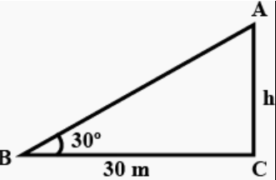
Given that, the angle of elevation of the top of a tower from a point on the ground which is 30 m away from the foot of the tower is 30∘.
To find out: The height of the tower.
Let the height of the tower be h and B be a point on the ground 30 m away from the tower.
Consider, the right angled △ABC, as shown in the above figure.
We know that, tanB=Opposite Side/Adjacent side​=AC​/BC
∴ tan 30°=h​/30
We know that, tan30°=1/√3
∴1/√3 ​=h/30​
⇒h=​
⇒h=​30​/√3*√3/√3=30√3/3
∴ h=10√3​ m
Hence, the height of the tower is 10√3​ m.

5.A body observed the top of an electric pole at an angle of elevation of 60∘, when the observation point is 8 metres away from the foot of the pole. Find the height of the pole.
Options:
A. 8√3
B. 150√3
C. 25/√3
D. 125√3
Answer : A. 8√3

Solution
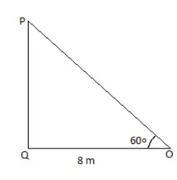
Let PQ be the electric pole.
Angle of elevation =∠QOP=60∘
In right angle △PQO,
tan(∠QOP)=PQ​/QO
or, tan60°=PQ​/8m
or, PQ=8×√3​m
or, PQ=13.86m

